**Objective**: At the end of this lab session students should be able to join tables and retrieve information

**Table joining – part 1**

Section 1

Part a - What is table joining?

When retrieving data from two or more related tables in a relational database, matching rows of tables are joined together to produce the answer. Here the rows of tables are combined, based on a related columns between them.

For example, suppose we want to make a list of names of students and the courses they have enrolled from our database. The corresponding rows of ‘Student’ and ‘Course’ tables are linked and the desired answer is obtained accordingly.

Section 2

Example

1. Display a list of Names of all employees with the corresponding Department names.

**Employee table**

|  |  |  |  |  |
| --- | --- | --- | --- | --- |
| **Ename** | **NIC** | **Eno** | **address** | **dnumber** |
| Smith,John B | 901250087V | 100 | 731 Fondren, Houston | 5 |
| Wrong, Franklin T. | 895290452V | 101 | 638 Voss, Houston | 5 |
| Zelaya, Alicia J. | 923859070V | 102 | 33321 Castle, Spring | 4 |

**Department table**

|  |  |
| --- | --- |
| **dno** | **dname** |
| 1 | Headquarters |
| 4 | Administration |
| 5 | Research |

# Step 01

Before answering, you need to look at the data in these two tables.

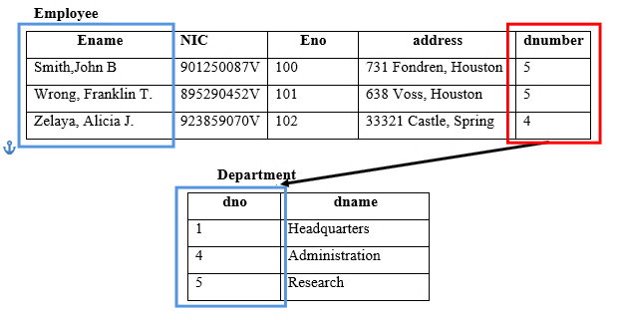

When you just look at these two tables, you can tell that both tables have the similar data in their Department number columns (dno , dnumber) . Employee table ‘dnumber’ column refer the data in Department table ‘dno’ column. Therefore we can join both of these tables using that ‘dno’ and ‘dnumber’ columns.

# Step 02

So let’s see how to make a query to get the answer.

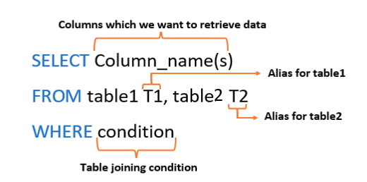

Figure 1: Table join syntax

**Alias**

Alias give a temporary name to a table or a column. An alias only exists for the duration of the query.

Now let’s create the query we want to get the answer.

**SELECT E.Ename, D. dname**

**FROM Employee E, Department D**

**WHERE E. dnumber = D. dno**

Here ‘E’ and ‘D’ are the aliases for Employee and Department tables respectively. Here the table joining condition must be specified correctly. Otherwise we get a wrong answer.

# Step 03

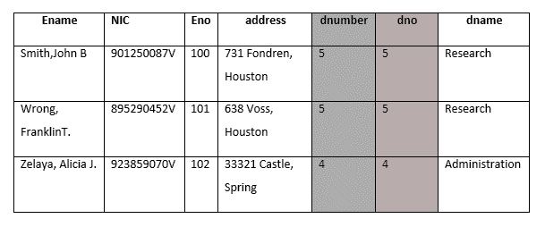Then both tables will get joined as in figure 2. The resulting table is given in figure 3.

Figure 2 : Joined table

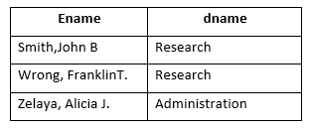

Figure 3: Output table

Exercise

1. Make a list of the student ID, name and the name of the course the student is following.
2. Make a list of the CIDs and the names of the modules offered by those courses.
3. Make a list of course names and the names of modules offered.
4. What are the ID and names of the students who have registered for the course by paying a registration fee of more than 1 Lak?
5. What are the names of modules offered to year I students by the Information Technology Course?